**AWS CSA-Pro Notes ACloudGuru Section 5 Migrations**

**Exam Tips:**

**Migration Strategies:**

**Understand the different strategies that companies might undertake when deciding if the cloud is right for them.**

**Re-Host:**

* “Lift and Shift”; simply move assets with no change
* Moving your on-prem MySQL database to an EC2 Instance

**Re-Platform:**

* “Lift and Reshape”; move assets but change the underlying platform
* Migrate on-prem MySQL database to RDS MySQL database

**Re-Purchase:**

* “Drop and Shop”; abandon existing and purchase new
* Migrate legacy on-prem CRM system to salesforce.com

**Re-Architect:**

* Redesign application in a cloud-native manner
* Create a server-less version of legacy application

**Retire:**

* Get rid of application which are not needed
* End-of-life the label printing app because no one uses it anymore

**Retain:**

* “Do nothing option”; decide to reevaluate at a future date
* Keep existing on-prem servers the same

**Understand the typical trade-offs and relative benefits for each strategy.**

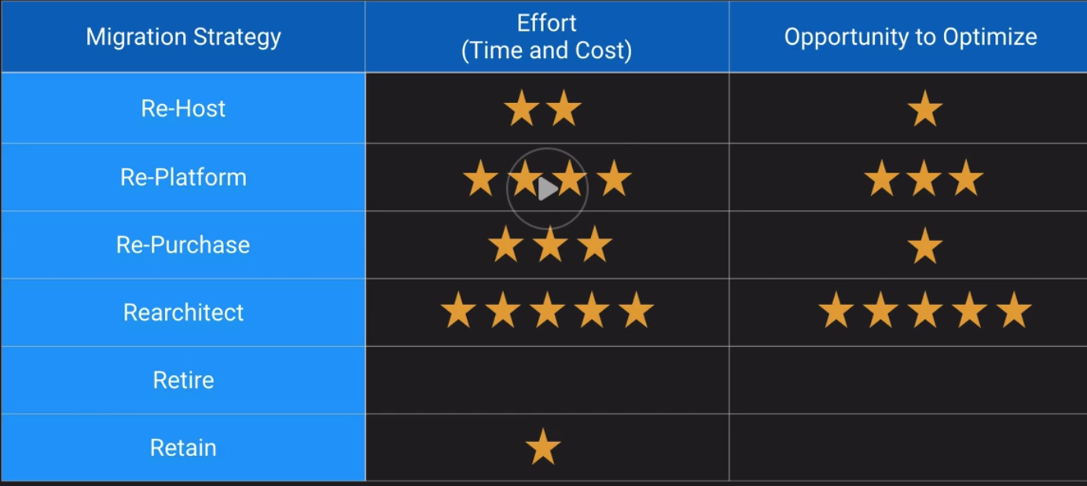

**Cloud Adoption Framework:**

**Know what a “framework” is and the realistic expectations that should accompany it.**

* A framework is some information to help you get your mind around a problem and is open for localization and interpretation
* It should be adopted and transformed based on your companies needs

**Understand the high-level components of the Cloud Adoption Framework.**

* A framework that takes a holistic approach to cloud adoption
* Business, people, governance, platform, security, and operations are all portions of the framework

**Most importantly, know that cloud adoption is only partially a technology effort.**

* For example, with the cloud adoption framework it has 6 portions which 3 of our from a non-tech perspective
* Those 3 are Business, People, and Governance

**Hybrid Architectures:**

**Be able to speak to some typical hybrid architectures that leverage both on-prem and cloud assets.**

* Typical Hybrid Architectures:
  + AWS Storage Gateway from on-prem to AWS storing objects in S3
  + Having a DR plan in AWS while everything else is on-prem

**Know that VMware has some nifty tools for abstracting workloads across on-prem and cloud, such as the Import plug-in.**

* This allows transport of VMs to and from AWS

**Migrations:**

**Understand the different services and tools available for migrating servers, storage, and databases.**

* Storage Gateway, Snowball = Storage Migration
* Server Migration Service
* Database Migration Service

**Tool usage specifics won’t likely be on the exam, except maybe Storage Gateway.**

**Network Migration and Cutover:**

**Know various hybrid networking architectures. (networking chapter)**

* AWS managed VPN
* Direct Connect
* VPN and Direct Connect
* VPN Cloudhub
* Software VPN
* Transit VPC

**Understand that smooth transitions from and to VPN and Direct Connect can be done using BGP routing; abrupt route changes risk downtime.**

**Migration Strategies:**

**Re-Host:**

* “Lift and Shift”; simply move assets with no change
* Moving your on-prem MySQL database to an EC2 Instance

**Re-Platform:**

* “Lift and Reshape”; move assets but change the underlying platform
* Migrate on-prem MySQL database to RDS MySQL database

**Re-Purchase:**

* “Drop and Shop”; abandon existing and purchase new
* Migrate legacy on-prem CRM system to salesforce.com

**Re-Architect:**

* Redesign application in a cloud-native manner
* Create a server-less version of legacy application

**Retire:**

* Get rid of application which are not needed
* End-of-life the label printing app because no one uses it anymore

**Retain:**

* “Do nothing option”; decide to reevaluate at a future date
* Keep existing on-prem servers the same

**Cloud Adoption Framework:**

**TOGAF:**

* The Open Group Architectural Framework
* Approach for designing, planning, implementing, and governing enterprise IT architectures
* De facto standard in EA practice

**TOGAF Criticisms:**

* Enterprise Architecture is not TOGAF
* But TOGAF often fills a vacuum
* Often misunderstood and victim of unreasonable expectations
* Not all practitioners are great practitioners
* TOGAF is not a cookbook
* People take it too literally
* “Architects just gonna architect”

Be a boundary spanner. Build bridges in your org. Don’t assume people know what you are talking about and be clear when presenting ideas to non-tech people.

**What is a Framework:**

* Is some information to help you get your mind around a problem
* Is open for localization and interpretation
* Is something you should adapt to your orgs culture
* It is not a perfect step-by-step recipe to success
* Is not something to hide behind with big words

**Typical Cloud Adoption Phases:**

**Project:**

* In the project phase, you are running projects to get familiar and experience benefits from the cloud

**Foundation:**

* After experiencing the benefits of cloud, you then build the foundation to scale your cloud adoption
* This includes creating a landing zone (making AWS organizations, secure, multi account environment)
* Assume security and compliance readiness

**Migration:**

* In this stage, you migrate your existing applications including mission-critical applications or entire data centers to the cloud as you scale your adoption across a growing portion of your IT portfolio

**Reinvention:**

* Now that your operations are in the cloud, you can focus on reinvention by taking advantage of the flexibility and capabilities of AWS to transform your business

**Cloud Adoption Framework:**

* There is more to cloud adoption than technology
* To fully unlock the potential benefits of a cloud migration, a holistic approach must be considered

**Business:**

* Creation of a strong business case for cloud adoption
* Business goals are congruent with cloud objectives
* Ability to measure benefits (ROI/TCO)

**People:**

* Evaluate org roles and structures, new skills and process needs, and identify gaps
* Incentives and career management aligned with evolving roles
* Training options appropriate for learning styles

**Governance:**

* Portfolio management geared for determining cloud eligibility and priority
* Program and project management more agile projects
* Align KPIs with newly enabled business capabilities

**Platform:**

* Resource provisioning can happen with standardization
* Architecture patterns adjusted to leverage cloud-native
* New application development skills and processes enable more agility

**Security:**

* IAM modes change
* Logging and audit capabilities will evolve
* Shared responsibility model removes some and adds some facets

**Operations:**

* Service monitoring has potential to be highly automated
* Performance management can scale as needed
* Business continuity and DR takes on new methods in the cloud

**Hybrid Architecture:**

* Hybrid Architectures make use of cloud resource along with on-prem resources
* Very common fist step as a pilot for cloud migrations
* Infrastructure can augment or simple be extensions of on-prem platforms
* Ideally, integrations are loosely coupled – meaning each end can exist without extensive knowledge of the other side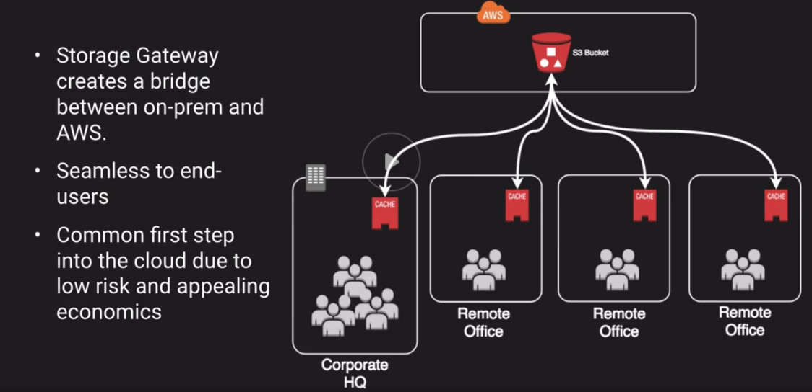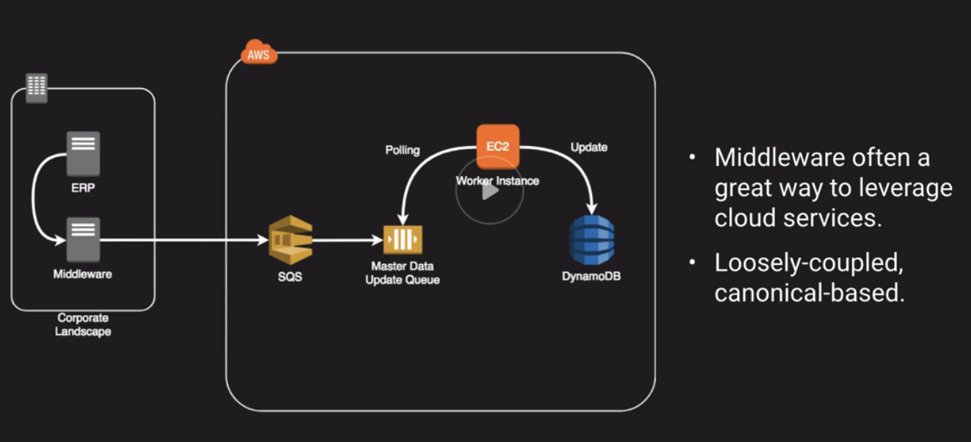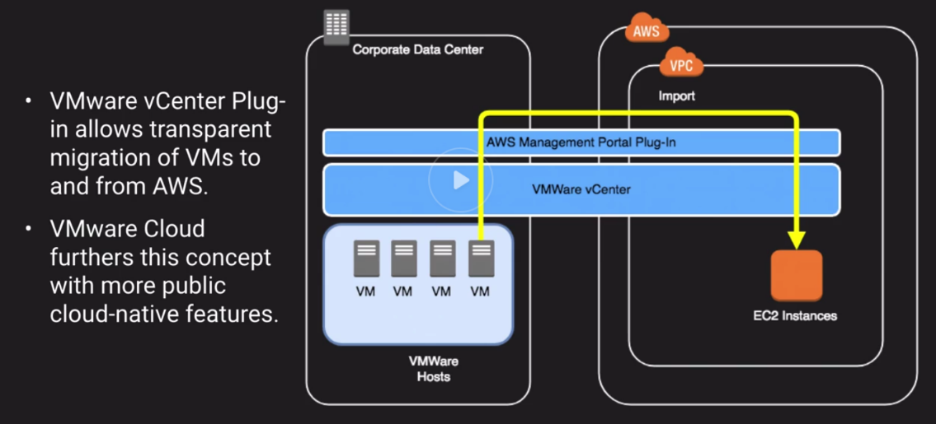

**Migration Tools:**

* Storage Migration
* Server Migration Service
* Database Migration Service
* Application Discovery Service
* AWS Migration Hub

**Storage Migration:**

**AWS Storage Gateway**

**AWS Snowball**

**Server Migration Service:**

* Automates migration of on-prem VMware, VSphere, or Microsoft Hyper-V/SCVMM virtual machines to AWS
* Replicates VMs to AWS, syncing volumes and creating periodic AMIs
* Minimizes cutover downtime by syncing VMs incrementally
* Support Windows and Linux VMs only
* The Server Migration Connector is downloaded as a virtual appliance into your on-prem vSphere or Hyper-V setup

**Database Migration Service:**

* Data Migration Service along with the Schema Conversion Tool (SCT) helps customers migrate databases to AWS RDS or EC2-based Databases
* The Schema Conversion Tool can copy database schemas for homogenous migrations and convert schemas for heterogeneous migrations
* DMS is used for smaller, simpler conversions and also supports NoSQL
* SCT used for larger, more complex datasets like data warehouses
* DMS has replication function for on-prem to AWS or to Snowball or S3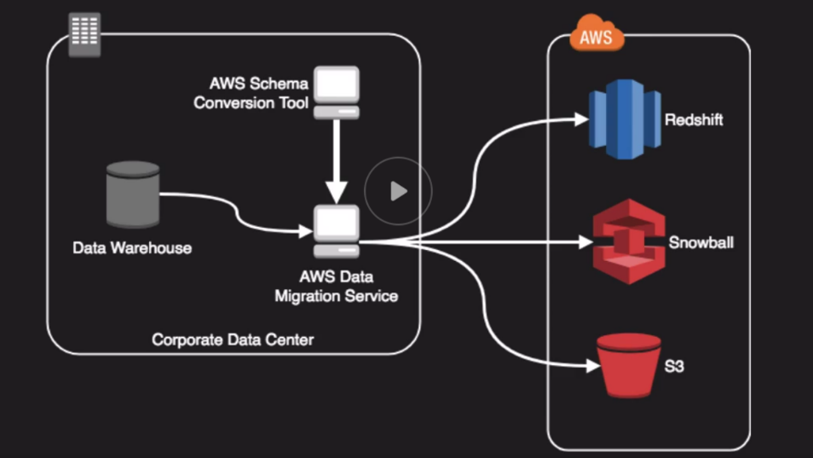

**Application Discovery Service:**

* Gathers info about on-prem data centers to help in migration planning
* Often customers don’t know the full inventory or status of all their data center assets, so this tool helps with that inventory
* Collects config, usage and behavior data from your servers to help in estimating TCO of running in AWS
* Can run as agent-les or agent-based
* Linux and Windows only

**AWS Migration Hub:**

* Project view of all the previously talked about services

**Network Migrations and Cutovers:**

**CIDR Reservations:**

* Ensure your IP addresses will not overlap between VPC and on-prem
* VPCs support IPv4 netmasks range from /16 to /28
* /16 = 255.255.0.0 = 65,024
* /28 = 255.255.255.240 = 16
* 5 IPs are reserved in every VPC subnet (example: 10.0.0.0/24)
* 10.0.0.0 = Network Address
* 10.0.0.1 = Reserved by AWS for the VPC router
* 10.0.0.2 = Reserved for AWS DNS
* 10.0.0.3 = Reserved for AWS future use
* 10.0.0.255 = Broadcast

**Network Migrations:**

* Most orgs start with a VPN connection to AWS
* As usage grows, they might choose Direct Connect but keep the VPN as a backup
* Transition from VPN to Direct Connect can be relatively seamless using BGP
* Once Direct Connect is set-up, configure both VPN and Direct Connect within the same BGP prefix
* From the AWS side, Direct Connect is always preferred
* Make sure the Direct Connect path is the preferred route from your network to AWS and not VPN (do this through BGP weighting or static routes)

**Snow Family:**

* Evolution of AWS Import/Export process
* Move massive amounts of data to and from AWS
* Data transfer is as fast or as slow as you are willing to pay a common carrier
* Encrypted at REST

**AWS Import/Export:**

* Ship an external hard drive to AWS
* Someone at AWS plugs it in and copies your data to S3

**AWS Snowball:**

* Ruggedized NAS in a box AWS ships to you
* You copy over up to 80TB of your data and ship it back to AWS
* They copy it over to S3

**AWS Snowball Edge:**

* Same as snowball, but with onboard Lambda and Clustering
* Local processing power
* Capture and process data in a very remote location
* On an Airplane, In a dessert

**AWS Snowmobile:**

* Shipping container full of storage (up to 100PB) and a truck to transport it

**Extra:**

What is the difference between Storage Gateway Stored Volume and Storage Gateway Cached Volume?

* Cached has only frequently accessed data on-prem and everything in AWS
* Stored is having all data on both AWS and on-prem and the data gets asynchronously backed to AWS from on-prem

What Database types does the Schema Conversion Tool and the Database Migration Service support? What type of Relational Databases and Non-Relational Databases does each support?

* Database Migration Service is used for smaller, simpler conversions and also supports NoSQL
* The Schema Conversion Tool can be used to convert different DB types and is used for bigger data conversions